Protein Power Breakfast Bowl
(Replaces cereal + toast)

Why this works
Starts the day with protein and fat → prevents mid-morning crashes and cravings.
Ingredients
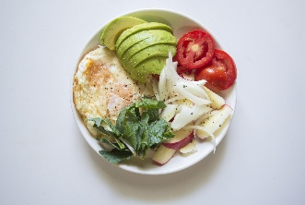
- 2–3 eggs
- Large handful spinach
- ½ avocado
- 1 tbsp olive oil
- 1 tbsp pumpkin or sunflower seeds
- Sea salt & black pepper
Method
- Sauté spinach in olive oil.
- Scramble or fry eggs in same pan.
- Add sliced avocado and seeds.
- Season well.
Optional carb (slow release):
Add a small portion of roasted sweet potato if training or very active.

2️⃣ Mediterranean Steak & Veg Plate
(Replaces sandwich lunch)

Why this works
High protein + fibre + olive oil = steady energy for hours.
Ingredients
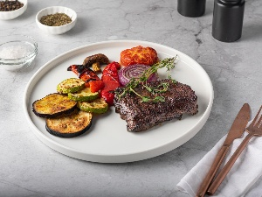
- 1 steak (grass-fed if possible)
- Courgette, peppers, red onion
- Handful rocket leaves
- 1–2 tbsp olive oil
- Squeeze lemon
- Sea salt
Method
- Grill steak to preference.
- Roast vegetables in olive oil at 200°C for 20 mins.
- Serve over rocket with lemon + olive oil drizzle.
Swap idea:
Instead of bread → add extra greens or a small portion of quinoa if needed.

3️⃣ Gut-Friendly Turkey Lettuce Wraps
(Replaces wraps or white bread rolls)

Why this works
Removes refined flour → keeps protein high and digestion lighter.
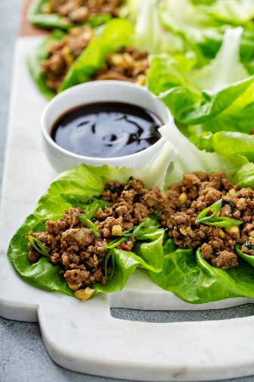
Ingredients
- 500g turkey mince
- 1 tsp paprika
- 1 tsp garlic
- Large lettuce leaves
- ½ avocado
- Chopped mushrooms
- Olive oil
Method
- Brown turkey in olive oil with spices.
- Add mushrooms and cook.
- Spoon into lettuce leaves.
- Top with avocado and fresh herbs.
Optional add:
Small spoon of fermented cabbage for gut support.

4️⃣ Salmon, Greens & Olive Oil Plate
(Replaces pasta dinner)

Why this works
High omega-3 fats → anti-inflammatory, supports metabolic health.
Ingredients
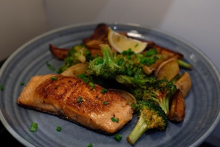
- 1 salmon fillet
- Broccoli or asparagus
- 1 tbsp olive oil
- Butter (optional)
- Lemon
Method
- Pan-sear salmon 3–4 mins per side.
- Steam greens.
- Drizzle olive oil and lemon over everything.

5️⃣ Fibre & Filter Salad
(Your “diesel engine filter change” analogy meal)

Why this works
Vegetable fibre acts like a metabolic filter → supports gut clearance and detox pathways.
Ingredients
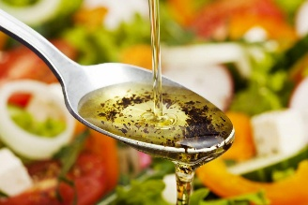
- Mixed leaves
- Grated carrot
- Cucumber
- Red cabbage
- Pumpkin seeds
- 1–2 tbsp olive oil
- ½ teaspoon lemon juice
Serve alongside protein (chicken, beef, fish, eggs).

 Chocolate Avocado Chia Pudding
[Serves 2]
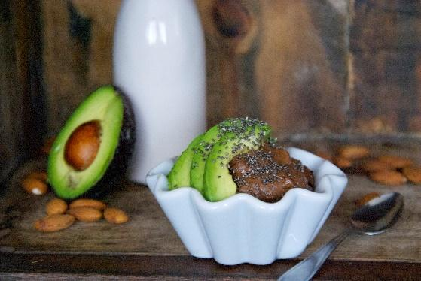
INGREDIENTS
160ml milk
20g chia seeds
1 avocado, small
1 teaspoon cacao powder
Honey to taste

Mix all ingredients in a blender
and refrigerate for 3-4 hours or overnight.
The avocado adds a creamy texture and good essential fatty acids

7–Day Refined-Carb Free Sample Plan

Day 1

Breakfast
Eggs, spinach, avocado, pumpkin seeds
Lunch
Grilled steak, roasted courgette + peppers, rocket, olive oil
Snack
Full-fat Greek yogurt, berries, chia seeds
Dinner
Salmon, broccoli, olive oil drizzle

Day 2

Breakfast
3-egg omelette with mushrooms + onions
Lunch
Chicken salad with mixed leaves, cucumber, olive oil
Snack
Apple + tablespoon almond butter
Dinner
Turkey mince lettuce wraps with avocado

Day 3

Breakfast
Protein smoothie: berries, flaxseed, protein powder, almond milk
Lunch
Beef stir-fry with broccoli, peppers (no noodles)
Snack
2 boiled eggs + carrot sticks
Dinner
Baked cod, asparagus, olive oil

Day 4

Breakfast
Scrambled eggs + smoked salmon
Lunch
Leftover beef over mixed greens
Snack
Handful mixed nuts
Dinner
Roast chicken, green beans, olive oil
Optional: small portion roasted sweet potato if training day.

Day 5

Breakfast
Chia pudding (chia + almond milk) + berries
Lunch
Tuna salad, olives, cucumber, olive oil
Snack
Cottage cheese + ground seeds
Dinner
Lamb chops, roasted vegetables

Day 6

Breakfast
Fried eggs + avocado
Lunch
Chicken lettuce wrap bowl
Snack
Square 85% dark chocolate
Dinner
Beef burger (no bun), large side salad, olive oil poached rather than grilled and charred

Day 7

Breakfast
Green protein smoothie (spinach, protein powder, berries)
Lunch
Leftover roast chicken salad
Snack
Pear + handful walnuts
Dinner
Grilled salmon, mixed vegetables, olive oil

