Bowel Transit Time Test

A bowel transit time test measures how long it takes for food to travel through the digestive tract. Bowel transit time depends on what types of food you eat and how much you drink. For example, people who eat lots of fruits, vegetables, healthy fats and whole grains tend to have shorter and faster transit times than people who eat mostly sugars and starches.

Because different people have different transit times, the results may not consistent. It can be repeated easily and cheaply to observe if changes occur when foods are removed and reintroduced. It may be useful to help identify if a specific food is influencing the digestive system - either speeding up or slowing down elimination. An example is coffee.

After you chew and swallow your food, it moves into your stomach, where it is mixed with acid and digestive enzymes. After your food leaves your stomach, it is squeezed through your small intestine, where, vitamins and water are absorbed for use by your body. The food then goes into your large intestine (colon). Whatever hasn't been digested and absorbed by your intestines combines with water, bacteria, and other waste products and becomes stool (faeces). Stool is expelled from your body through your anus/bum. The time it takes for food to travel from your mouth to your anus as stool is your bowel transit time.

There are several methods to test your bowel transit time. Each method uses a swallowed substance (called a food marker) that goes through your body and leaves in your stool without being digested. Yellow corn kernels are usually quite obvious in the toilet through the stool. I would recommend a jar of Biona Organic or Demeter corn. As unfortunately some people are sensitive to genetically modified/GM corn and soy foods please use an alternative.

Not everyone has red in the urine or stool after eating cooked red beetroot but it is quite obvious when it does come through the system.

How It Is Done
For the home test, to serve as markers
- eat either large helping of white sesame seeds,
- or some cooked Organic/Demeter beetroot from a jar,
- or cooked Organic sweetcorn kernels.
Look at your next couple of bowel movements and write down how many hours it takes after eating to when the markers appear in your stool.

Why It Is Bowel transit time test done?
- Help investigate severe constipation.
- Show how different foods speed up or slow down movement of food through the body.
- Bowel transit time tests are not done to find the cause of diarrhoea or constipation.
- Absorption of nutrients is affected is badly affected if to fast
- Wind, trapped gas, constipation and bloating nausea can result from too slow transit

How To Prepare
- If you plan to use food markers (such as corn or beets) to measure bowel transit time at home, do not eat these foods for about a week before starting the test.

Results
A bowel transit time test measures how long it takes for food to travel in the digestive tract.
Bowel transit time depends on what types of food you eat and how much you drink. Different people have different bowel transit times. Talk to your doctor if you do a bowel transit test at home and you do not think that the results are normal.

Bowel transit time
Normal: | The food marker shows up in the stool within 14 to 24 hours.  The last food marker shows up within 36 to 48 hours.
Slowed: | The food marker takes more than 72 hours to show up in the stool.

What Affects the Test?
- You may have an abnormal bowel transit time if you:
- Have an infection in your intestines.
- Do not drink enough fluids (dehydration).
- Are eating less than you usually do or you are eating different kinds of food than usual.
- Take medicines, such as cold medicines, iron, or medicine used to control blood pressure and pain.
- Women normally have slower bowel transit times than men.

What To Think About
- Different people have different bowel transit times on different days.
- You can usually speed up bowel transit time if you increase the amount of fruits, vegetables, cold pressed organic oils like flax and whole grains that you eat each day.
- It is possible to have a daily bowel movement but still have a slow bowel transit time.
- Caffeine intake can be an irritant to the digestive tract
- 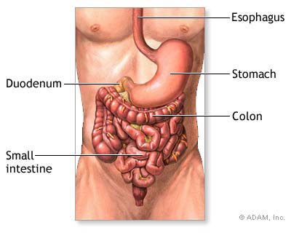Lack of exercise will affect time.

Adapted from:National Institutes of Health, Medline Plus Medical Encyclopedia (2005). Bowel transit time. Available online: http://www.nlm.nih.gov/medlineplus/ency/article/003887.htm. Image Adam.Inc

